🧠 PART A: CONCEPTUAL FOUNDATION
ENSEMBLE LEARNING — THEORY ANSWERS
Answer briefly (2–4 lines each) • Clear concepts • Visual learning
Q1. What are Ensemble Learning Methods and why are they effective?
Answer: Ensemble Learning combines predictions from multiple models to produce a stronger final prediction. It is effective because different models can capture different patterns, reducing overall error and improving stability and generalization.
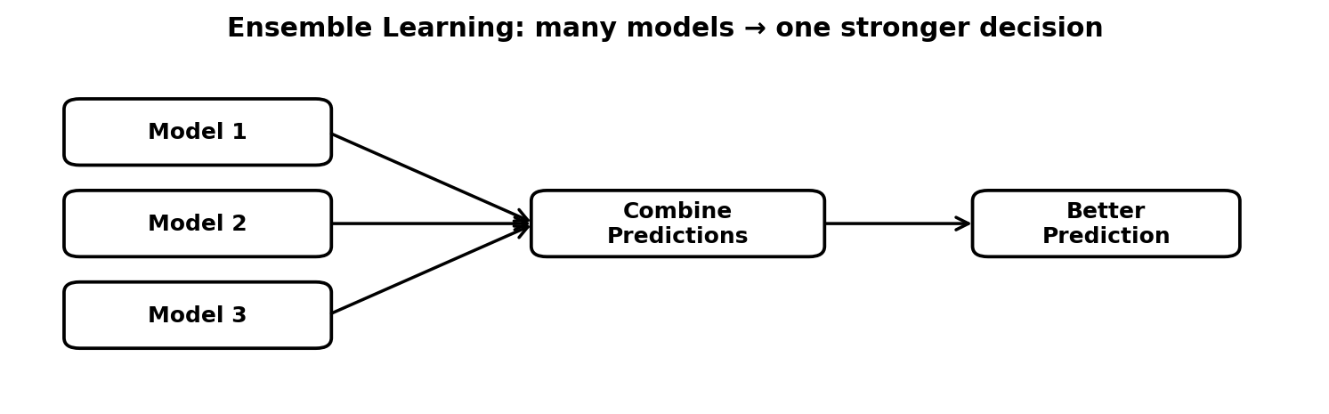
Multiple models cooperate to improve prediction quality.

Q2. Explain the difference between Bagging, Boosting, and Voting.
Answer: Bagging trains models independently and combines them, mainly reducing variance. Boosting trains models sequentially, with later models focusing on previous errors, mainly reducing bias. Voting combines predictions from different models using majority vote or averaged probabilities.
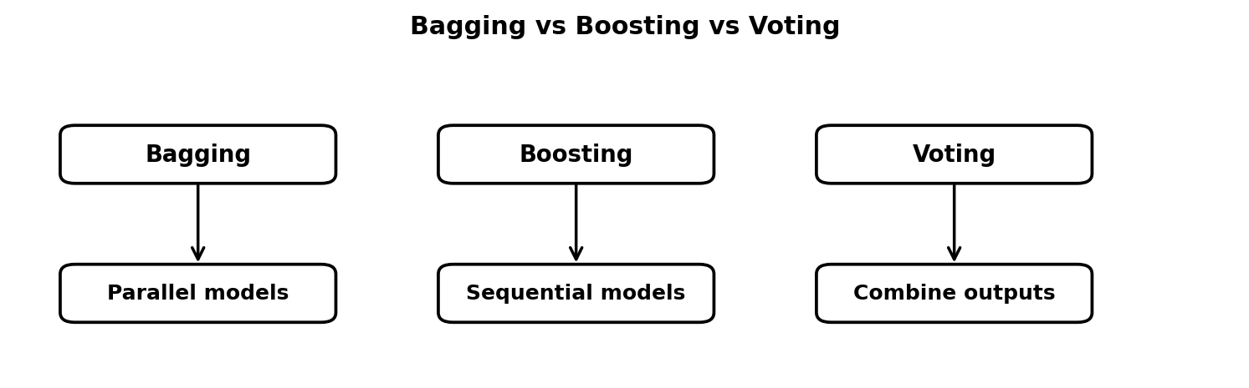
The key difference is how models are trained and how outputs are combined.

Q3. What is Bias–Variance Trade-off, and how do ensemble methods address it?
Answer: Bias is error from an overly simple model, while variance is error from a model that is too sensitive to training data. Ensembles help balance them: Bagging mainly reduces variance, while Boosting mainly reduces bias, leading to better generalization.
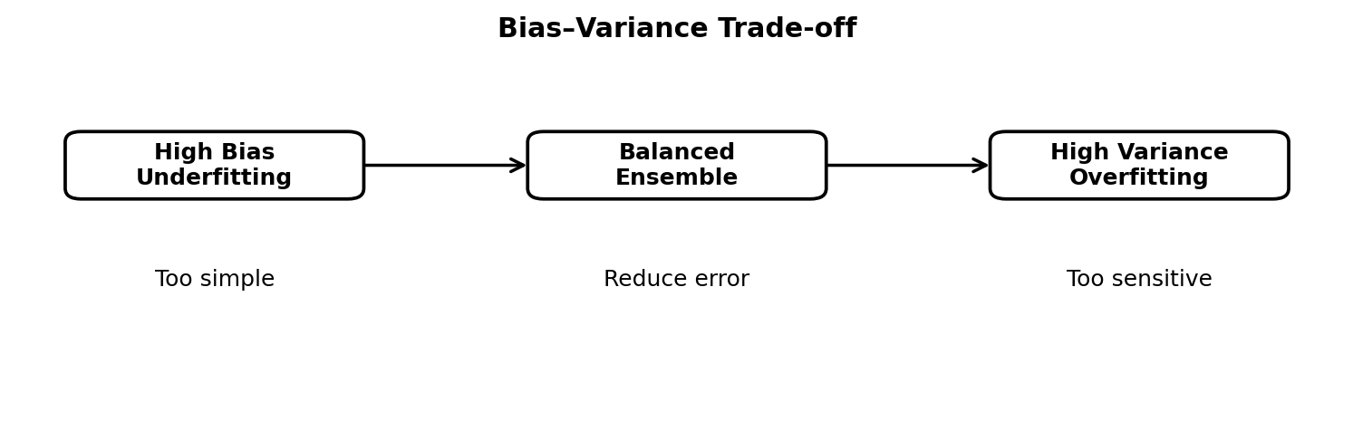
A good ensemble seeks lower total error without becoming unstable.

Q4. Explain Voting Classifier and Stacking Ensemble.
Answer: A Voting Classifier combines predictions from several classifiers using hard voting (majority class) or soft voting (average probabilities). Stacking goes one step further by training a meta-model to learn how to combine the base-model predictions.
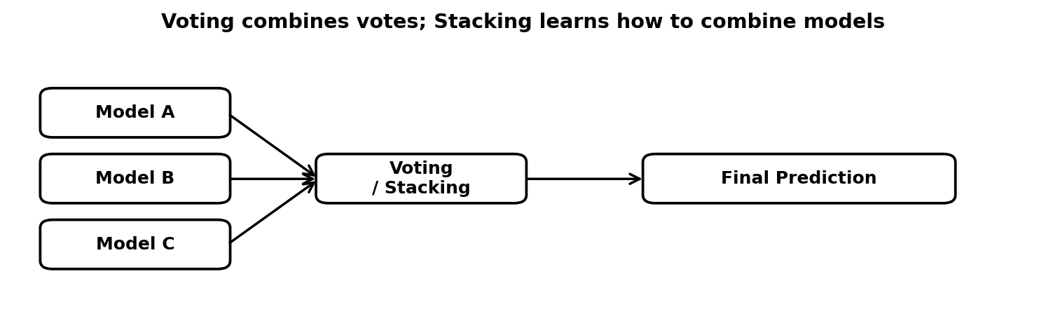
Voting uses a direct rule; stacking learns the combination rule.

Q5. Compare AdaBoost, Gradient Boosting, LightGBM, and XGBoost conceptually.
Answer: AdaBoost focuses more on misclassified samples by increasing their weights. Gradient Boosting fits new trees to reduce residual errors. XGBoost adds strong regularization and engineering optimizations, while LightGBM uses histogram-based, leaf-wise tree growth for high speed and large datasets.
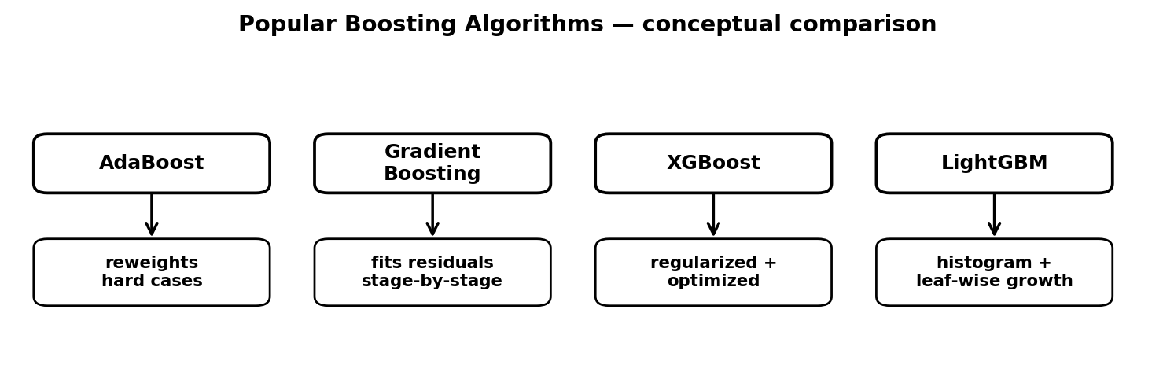
Each method improves weak learners in a different way.

